Question 1

Design the flowchart and pseudocode to calculate the salary of an employee.

* + Initialize all the variables.
  + Get the salary, bonus and deduction from the user
  + Calculate the net salary
  + Display the salary, bonus, deductions and net salary

1.1 Flow chart to calculate the salary of an employee

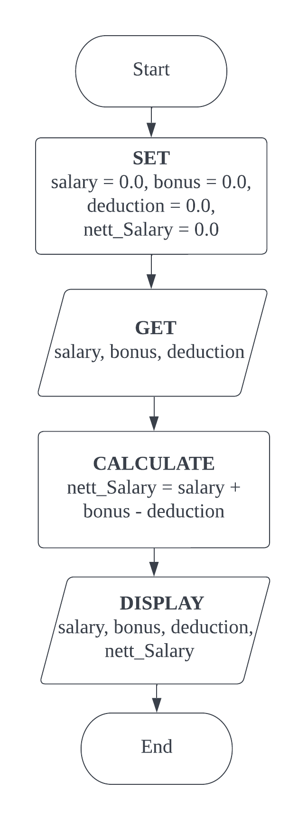

1.2 Pseudocode to calculate the salary of an employee

**BEGIN**

**SET** salary = 0.0, bonus = 0.0, deduct = 0.0, nettSalary = 0.0

**GET** salary, bonus, deduction

**CALCULATE** nettSalary = salary + bonus – deduction

**DISPLAY** salary, bonus, deduction, nettSalary

**END**

Question 2

Design the flowchart and pseudocode to calculate the Body Mass Index (BMI) of a person.

* Initialize all the variables.
* Get the height and weight from the user.
* Calculate the BMI (BMI = weight / height ²)
* Identify the status based on the BMI and by referring to the following table.
* Display the status

|  |  |
| --- | --- |
| BMI | Status |
| Less than 18.5 | Underweight |
| 18.5 - 24.9 | Normal |
| 25.0 - 29.9 | Overweight |
| More than or Equal 30.0 | Obese |

2.1 Flow chart to calculate the Body Mass Index (BMI) of a person.

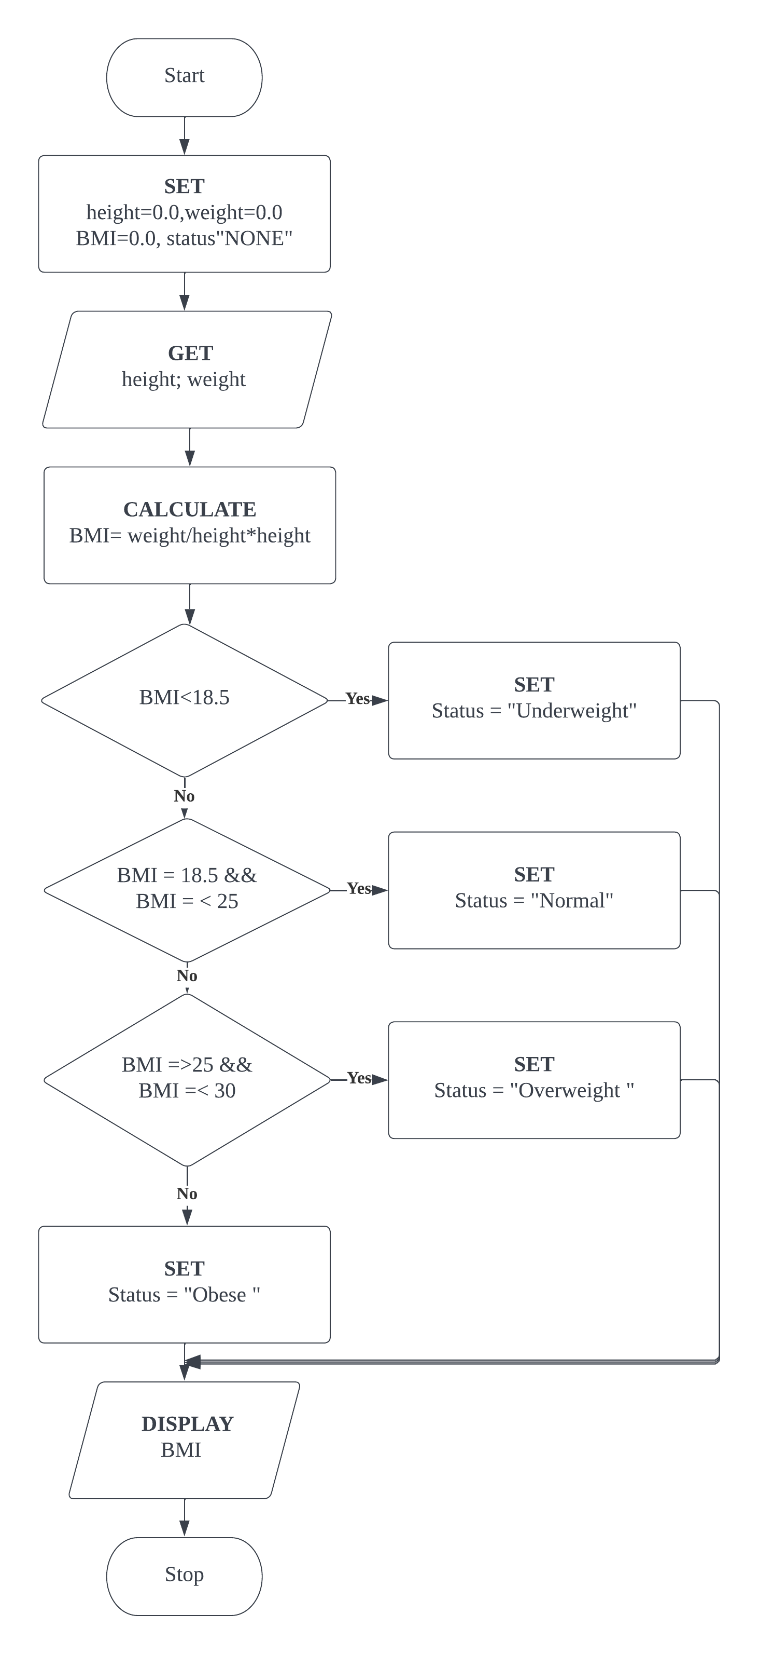

2.2 Pseudocode to calculate the Body Mass Index (BMI) of a person.

**BEGIN**

**SET** height =0.0, weight=0.0, BMI=0.0, Status= “None”

**GET** Height

**CALCULATE** BMI = weight/height*height

**IF** BMI <18.5 **THEN**

**SET** Status = “Normal”

**ELSE**

IF BMI>=25 && BMI<30 THEN

**SET** status = “Overweight”

**ELSE**

**SET** status = “Obese”

**ENDIF**

**ENDIF**

**ENDIF**

**DISPLAY** BMI

**END**

Question 3

The weight of an object is defined as the force of gravity which is exerted on it by Earth. Scientists put that setence into an equation by writing w = m x a where w is the weight of an object, m represents the mass of an object and a represents the acceleration of gravity. You are required to   
calculate the weight of 4 different objects. Therefore, the program is required to be repeated 4 times so that 4 new sets of data can be entered to get the respective weights.

* Initialize all the required variables
* Get the inputs of mass and acceleration from the user
* Calculate the weight. Display the weight, mass and acceleration
* Repeat the whole process 4 times using a loop for different objects

a) Based on the description give above, draw the **flowchart**. Use **do while loop** structure

3.1 Flowchart for do **while loop** structure

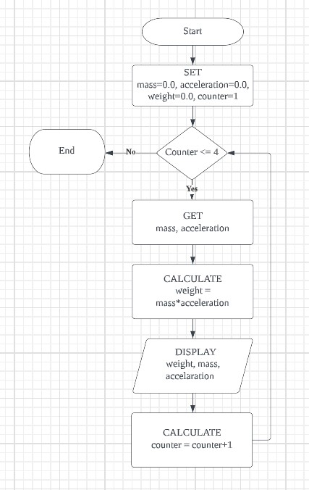

3.2 Pseudocode for **do while loop** structure

BEGIN

SET mass = 0.0, acceleration=0.0, weight=0.0, counter=1

WHILE counter<=4

GET mass, acceleration

CALCULATE weight = mass * acceleration

DISPLAY weight, mass, acceleration

CALCULATE Counter = counter + 1

ENDWHILE

END

3.3 Flowchart for **while loop** structure

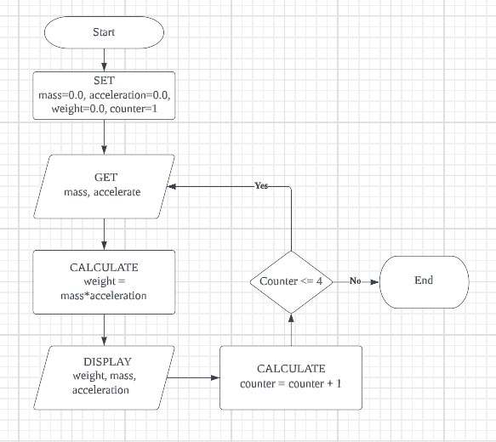

3.4 Pseudocode for **while loop** structure

BEGIN

SET mass=0.0, acceleration=0.0, weight=0.0, counter=1

DO

GET mass, acceleration

CALCULATE weight = mass * acceleration

CALCULATE counter = counter + 1

WHILE counter <=4

ENDDO

END

4. Table 1 shows the revenue and cost of E&A Company for the past three months.

|  |  |  |  |
| --- | --- | --- | --- |
|  | Jan | Feb | March |
| Revenue | 20000 | 26000 | 30000 |
| Cost | 15000 | 20000 | 35000 |

* Initialize all the required variables.
* Get the inputs of revenue and cost from the user.
* Display the profit/loss status.
* Repeat the process

1. Design a flowchart to help E&A Company to identify whether it is making profit or loss for each month. Use **while loop** structure.

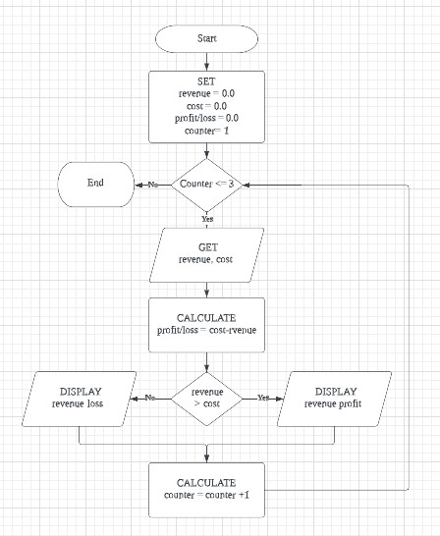

b) based on the decriptions in part (a), write the psudocode. Use **do-while** loop structure.

BEGIN

SET revenue=0.0, cost=0.0, profit/lost= 0.0

DO

WHILE counter <=3

GET revenue, cost

CALCULATE Profit/loss = cost

IF Revenue > cost THEN

SET status = Revenue profit

ELSE

SET status = Revenue loss

END IF

CALCULATE Counter = counter + 1

ENDWHILE

END